A Look Inside My Mind: Childhood Sneak Peaks to Now
Becoming an explorer of the world is a considerable part in starting to write. The world around us is the perfect place to draw inspiration from. Even when it feels like there’s nothing to write, taking a walk or just sitting on my back porch helps clear my mind. I feel at peace when I’m outside. There is so much beauty in the world around us that can be picked up, written, and expressed so beautifully in words. Who am I to keep the beauty that I see, from those who may not be able to see? I want to use my abilities to show the people around me and in my world the simplistic beauty in the things that I see. As I progress into a professional writer, I want my writing, my goals, and my words to reflect who I am and what I believe in. My world has been impacted by the world around me and I want to be able to give back to the world that I seemed so unaware of as a child. The world I grew up in seems to have given me the opportunity to set goals for my writing and my life.
I grew up very narrow minded, never having to struggle for many things. I was always provided for. As I have read more and experienced more, my mind has opened to see that my world is very different from the real world. I lived in your typical white middle-class family status. I went to public school through elementary, then I was switched to a private Christian school for middle and high school. I never had to listen to my parents argue about money or paying bills or worry about not having a roof over my head. This is how it always was. I never saw it as anything different. Honestly, I didn’t see that it could be different. It wasn’t until I was older that I realized that not everyone’s parents stayed married. Not everyone’s parents took their kids to church every weekend. Not everyone got to come home from school to two sober parents. I was blessed to be protected from that, but it also became an issue sometimes. I couldn’t relate with my friends all the time. When they were in a tough position, maybe financially, I was oblivious. This was the first time that I realized that all my experiences have shaped me into the explorer that I am today.
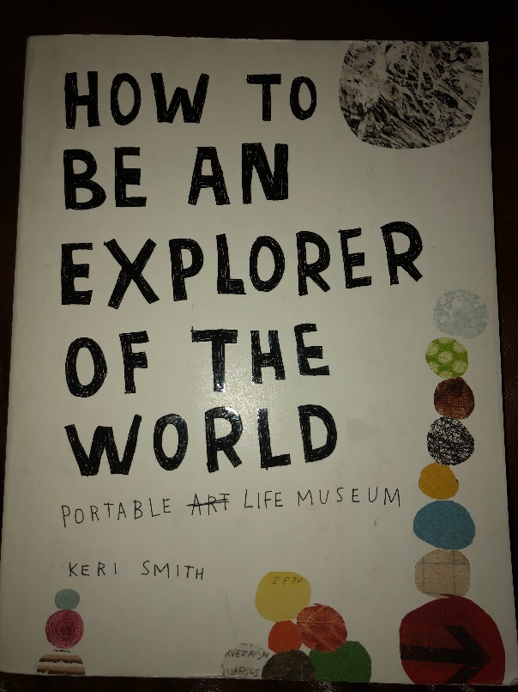
In my Advanced Composition class, we have been reading different texts to help us get in the mindset of being an explorer of the world. One book, in particular, that we have been reading through is How to be an Explorer of the World by Keri Smith. My initial thought to seeing this book was it looked like a children’s book. I thought this was and advanced composition class. What are we doing with a children’s book? Within this book are different explorations for the reader to do. Each exploration helps the reader to observe something in their everyday lives and look at it in a different way. As we read through the explorations as a class, I began to notice that this “children’s book” makes me think so much more than many of the other textbooks I have used for previous classes. There is so much that can be overlooked as it becomes “regular” or “comfortable.” The things that you see every day may have more of an impact on you than you may think. As I go through different explorations, I see that each one brings me back to a place in my childhood and it connects with where I am in my life and my mindset now.
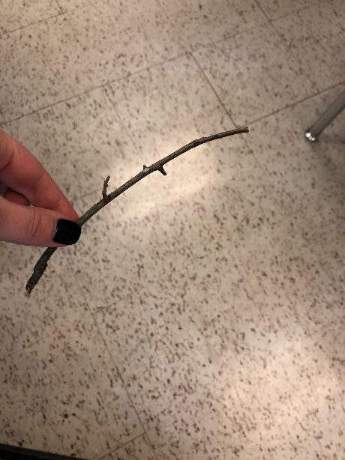
In Keri Smith’s book How to be an Explorer of the World, exploration 4 was one of the first explorations I did. It was to collect objects on my way to work/school every day. The first thing I noticed was a stick in the ground outside my dorm room. I picked it up and walked with it all the way to class. I wasn’t sure what I was supposed to do with it. The more I stayed with it, the more childhood memories came flooding to mind. I remember playing swords with my brothers, pretending the sticks were swords and running around the neighborhood. Just a simple stick really started to make me see the details in every little thing. There is more than meets the eye to everything. We can only see what’s on the outside of an object, person, animal, etc. It is about the inside of the object that makes it what it really is. This exploration made me see that not everyone is going to be exactly like me, think like me, see things like me, work like me, understand like me. But that’s okay. That’s what makes everyone beautiful and unique. Ultimately this world isn’t about me. It is easy to get so focused on the next task that needs to be done in my life and to neglect the fact that there is so much more going on around me.
Right now, I’m working on this and doing homework but to step back and think about all the other people and what all they could be doing. We all have such different lives. All across the world… we are just tiny little people but there is so much more to learn and discover in this world. Even someone so close to me has such a different life than I. One of my good friends went to the same private school as me, and she struggled financially. Her parents did not care about their finances as much as mine did. She had to go without things that I had that made me look like I was spoiled. Even though we had similar lives and were very close, there’s still so much that differentiates us from each other and our experiences.
The next exploration that stuck out to me was exploration 8. we were to map out pavement cracks in our neighborhood. Even though I wasn’t at home, I was able to visualize my home so clearly. All throughout my childhood, I spent a lot of time outside. I am very familiar with all the cracks because as I kid, I learned a jingle about cracks. “If you step on a crack, you’ll break your mother’s back.” Many of the neighborhood kids were very particular in where they stepped as to not step on a crack. I was that kid. This exploration brought me back to a simpler time where I was happy with no knowledge of ever being unhappy. When thinking of my home, I could feel the sun shining on my skin, my bare feet walking in the cul-de-sac, the sound of laughter mixed with the sound of a basketball dribbling on the pavement.
In my writing, I want to express where I have come from. I want to explore different styles of writing and different ways to express what I’ve come through and what I’ve got to offer. I want to be able to be personable in my writing. I want people to see me and be able to respect me. Even if they don’t agree with me, I want to be able to articulate in a way that is dignified. Whether that be in my personal blog, freelance writing, being hired as a writer for a company, whatever it may be, I want to be able to adequately write the story that I’m trying to get across. A poem by Terrance Hayes, ”What I Am”, has opened my eyes so much in relation to how I can write. This poem is very original and has been something that has taught me that writing does not just have to be academic. It can be free. My writing can be whatever I see fit for it to be. This poem helped me get outside of my comfort zone and begin working on a new style of writing than I am used to. I don’t have to be confined to writing for a professor or writing for an assignment. I can let my writing express whatever I want. It can be political, religious, light-hearted. There are no restraints for what I can do. In my first writing after realizing this, I explored my options in a poem. Your Brokenness is Welcome Here was my first endeavor on exploring writing varieties. The more I read, the more I have an inspiration for more writing.
In Advanced Composition, we also read Why Keep a Field Notebook by Erick Greene. This opened my eyes to the idea of keeping track of my thoughts. Anytime I have an idea, I should write it down. Without a notebook on hand, that thought could end up being lost. I love being able to go back and see what I was going through or what I was thinking on certain days. It brings back all the emotion and excitement that happened throughout that say. I’m able to use those thoughts and feelings to write in a more meaningful way.
”Learning the Grammar of Animacy” by Robin Wall Kimmerer and ”The Art of Seeing Things” by John Burroughs both helped me see my language and the things around me for the beauty that they have. Together, these articles, books, etc. have opened my eyes and widened my writing abilities. Before reading “Learning the Grammar of Animacy” I didn’t see language as something so valuable and worthy of preserving. It makes me want to write in my language as much as I can and learn as many other languages as I can. To obtain knowledge and share it with others is a goal that I feel, will never get old. “The Art of Seeing Things” allowed me to observe things more intentionally. With the language I have and the resources around me, I can write about the simple things in my life, the things that seem insignificant. I can now see things as they are and appreciate the imperfections in them.
I want to soak in as much knowledge and information as I can to share to the people around me. My life isn’t about me. I don’t want to just be here and do nothing with my knowledge. I have been blessed to be a blessing. There is nothing more important to me than to show people the love that I have been given. Getting outside, appreciating the fresh air, and writing down my thoughts, my ideas, what’s going on in my life helps me to slow down and bring my thoughts together. Ultimately, allowing me to share the blessing that I have with the people around me. I am becoming an explorer of the world in taking the little details of my life and bringing them to light in the context of getting outside of myself. I tend to think that I am busy and have so much to do, but when I take a seat outside, I realize there is so much more to this life than the day to day tasks that seem so daunting. I can listen to the sounds of the breeze, the ducks in the pond, and the water from the fountain. All these things impact my mindset when I write. They help me slow down. They help me relax and write what I really want to write. I want to give people that same feeling of relax and peace that comes from slowing down the busyness of life.

Works Cited
Burroughs, John. “Story of the Week.” Friday Night Tykes, 2012, storyoftheweek.loa.org/2012/07/the-art-of-seeing-things.html.
Greene, Erick. “Chapter 12.” Field Notes on Science & Nature, by Michael R. Canfield, Harvard University Press, 2011, pp. 251–274.
Hayes, Terrance. “Poetry and Place.” Poets.org, Academy of American Poets, 6 Oct. 2015, www.poets.org/poetsorg/poem/what-i-am.
Kimmerer, Robin. “Robin Wall Kimmerer | Learning the Grammar of Animacy.” The MOON Magazine, 5 Jan. 2015, moonmagazine.org/robin-wall-kimmerer-learning-grammar-animacy-2015-01-04/.
Smith, Keri. How to Be an Explorer of the World Portable Life Museum. Penguin, 2016.

